- Problem Statement:
A software company is developing a user registration system. Before creating an account, the system must validate user credentials based on predefined security policies.
Develop a Python application that validates:
Email Address
Password
Mobile Number
using Regular Expressions.
Validation Rules
Email
Must start with an alphabet.
May contain letters, digits, '.', '_' before '@'.
Domain should contain only alphabets.
Valid extensions: .com, .org, .edu, .net, .in
Password
Minimum 8 characters
At least one uppercase letter
At least one lowercase letter
At least one digit
At least one special character (@,#,$,%,&,!)
Mobile Number
Must contain exactly 10 digits.
First digit should be between 6–9.
Expected Output
Display:

CODE:
import re

# Inputs
email = "khalandar123@gmail.com"
password = "Khalandar@123"
mobile = "9876543210"

# Email validation
email_pattern = r"^[A-Za-z][A-Za-z0-9._]*@[A-Za-z]+\.(com|org|edu|net|in)$"

if re.match(email_pattern, email):
print("Valid Email")
else:
print("Invalid Email")

# Password validation
password_pattern = r"^(?=.*[A-Z])(?=.*[a-z])(?=.*\d)(?=.*[@#$%&!]).{8,}$"

if re.match(password_pattern, password):
print("Strong Password")
else:
print("Weak Password")

# Mobile number validation
mobile_pattern = r"^[6-9][0-9]{9}$"

if re.match(mobile_pattern, mobile):
print("Valid Mobile Number")
else:
print("Invalid Mobile Number")
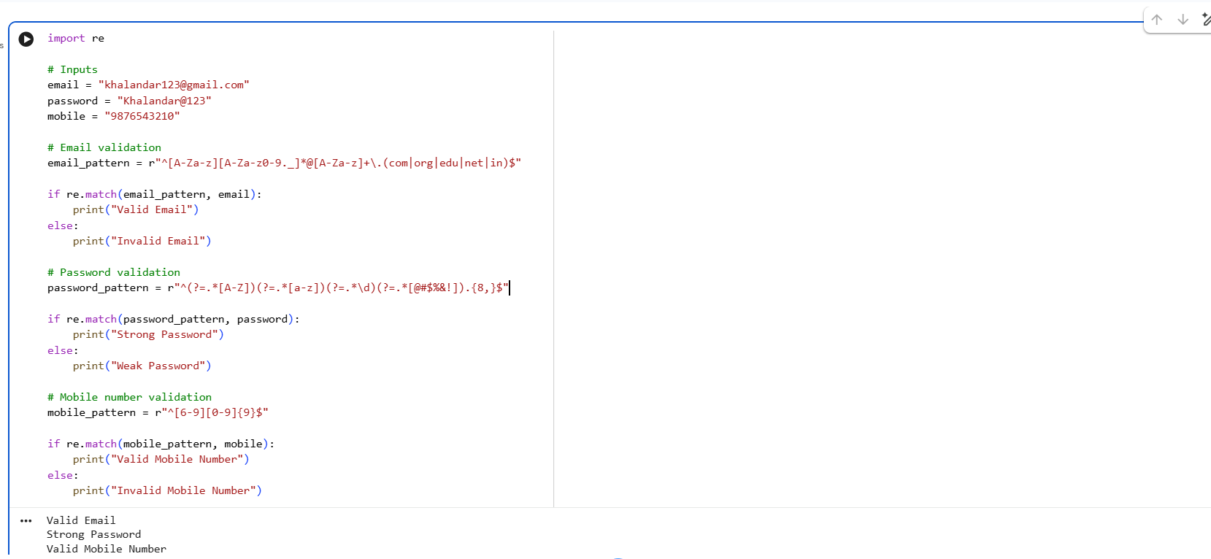

2.Problem Statement
Develop a Python-based Deterministic Finite Automata (DFA) simulator.
The program should:
- Accept the DFA description
    - States
    - Input alphabet
    - Transition table
    - Initial state
    - Final state(s)
- Accept multiple input strings.
- Simulate state transitions.
- Display whether the string is Accepted or Rejected.
Example
Language:
Strings ending with "ab"
Input
abaab
Output
Transition Path:
q0 → q1 → q0 → q1 → q2
# DFA Simulator
# Language: Strings ending with "ab"
# DFA description
states = ["q0", "q1", "q2"]
alphabet = ["a", "b"]
# Transition table
transition = {
"q0": {"a": "q1", "b": "q0"},
"q1": {"a": "q1", "b": "q2"},
"q2": {"a": "q1", "b": "q0"}
}
initial_state = "q0"
final_states = ["q2"]
# Input string
string = "abaab"
# Simulation
current_state = initial_state
path = [current_state]
for symbol in string:
current_state = transition[current_state][symbol]
path.append(current_state)
# Display result
print("Input:", string)
print("Transition Path:")
print(" → ".join(path))
if current_state in final_states:
print("Accepted")
else:
print("Rejected")
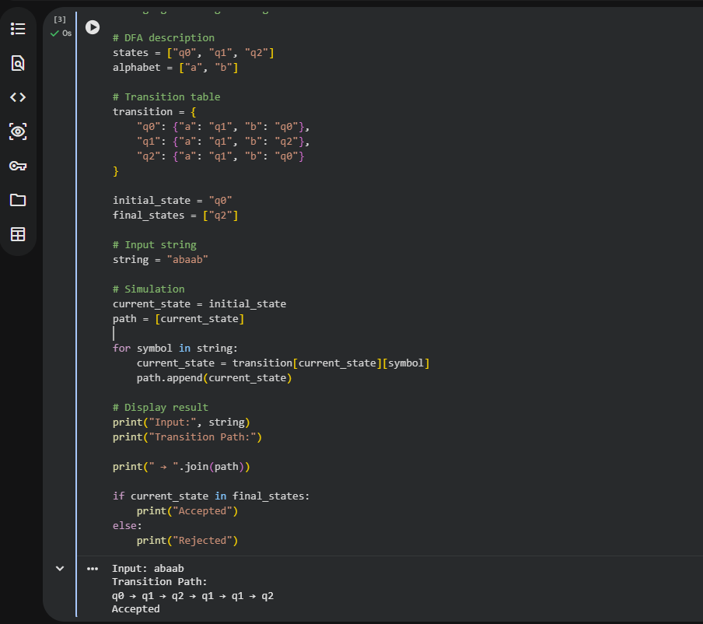

- Problem Statement

Develop a Python-based text search engine that performs pattern matching using Regular Expressions.
The system should support:
Word Search
Prefix Search
Suffix Search
Date Search
Phone Number Search
Hashtag Search
Mention (@username) Search
Example Input
Meeting on 12/09/2026
Call 9876543210
#NLP
@OpenAI
natural language processing
User Menu
1.Search Date
2.Search Phone Number
3.Search Hashtag
4.Search Mention
5.Search Prefix
6.Search Suffix
Expected Output
Display all matching patterns based on user selection.

Valid Email / Invalid Email
Strong Password / Weak Password
Valid Mobile Number / Invalid Mobile Number

CODE:
import r
# Input text
text = """
Meeting on 12/09/2026
Call 9876543210
#NLP
@OpenAI
natural language processing
"""
# User selection
choice = 1
# Menu
print("1. Search Date")
print("2. Search Phone Number")
print("3. Search Hashtag")
print("4. Search Mention")
print("5. Search Prefix")
print("6. Search Suffix")

print("\nSelected Option:", choice)
# Search Date
if choice == 1:
result = re.findall(r"\b\d{2}/\d{2}/\d{4}\b", text)
print("Dates:", result)
# Search Phone Number
elif choice == 2:
result = re.findall(r"\b[6-9]\d{9}\b", text)
print("Phone Numbers:", result)
# Search Hashtag
elif choice == 3:
result = re.findall(r"#\w+", text)
print("Hashtags:", result)
# Search Mention
elif choice == 4:
result = re.findall(r"@\w+", text)
print("Mentions:", result)
# Search Prefix
elif choice == 5:
result = re.findall(r"\bnatural\w*", text, re.IGNORECASE)
print("Prefix Matches:", result)
# Search Suffix
elif choice == 6:
result = re.findall(r"\b\w*ing\b", text, re.IGNORECASE)
print("Suffix Matches:", result)
else:
print("Invalid Choice")

